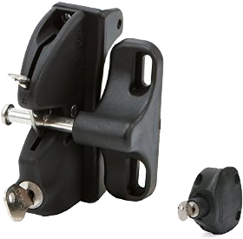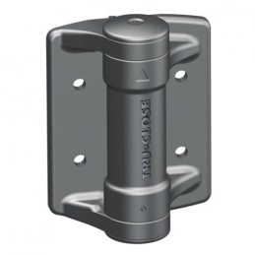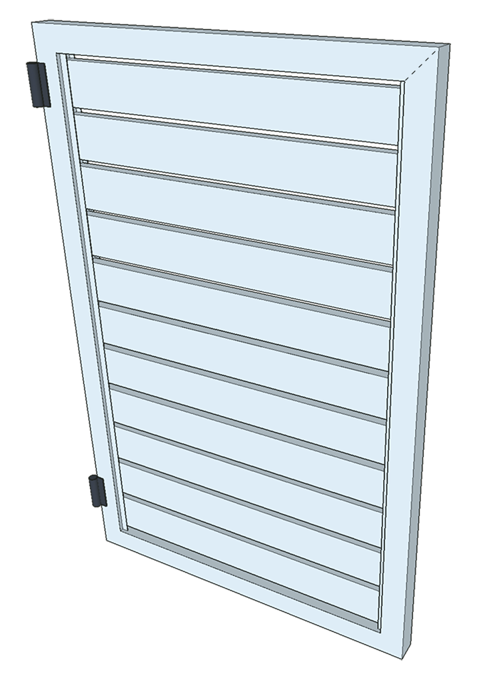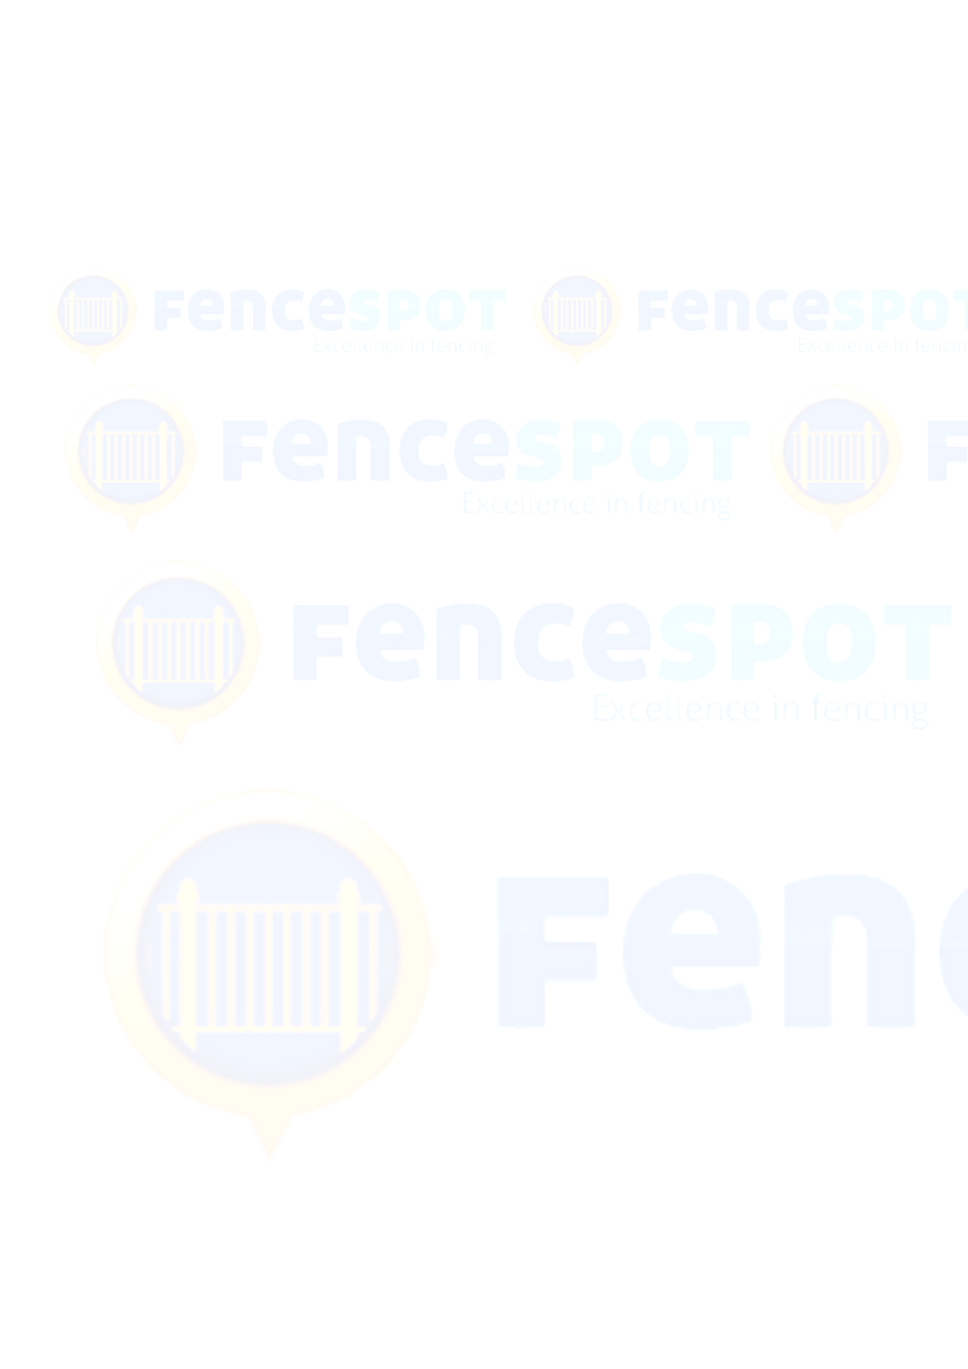

**FULLY WELDED H/DUTY FRAME WITH MITRED CORNERS**

**CHANNEL WITH CLIP-ON COVER TO CONCEAL SLAT FIXINGS**

**SLATS SPACING CAN BE VARIED TO SUIT INDIVIDUAL NEEDS**

**CHOICE OF WOODGRAIN OR COLOURED SLATS**

**DOUBLE SIDED LOKK LATCH DELUXE**Key lockable from both sides for security that can be ‘keyed’ to allow council ‘meter-reader’ access.  
  
Upgrade options available for electronic ‘intercom ready’ locks

**POWDER COATING IN ALMOST ANY COLOUR**  
That includes a multi-stage chemical pre-treatment prior to paint to meet the highest Australian standards

**HEAVY DUTY HINGES**  
That can be set to self-close for a reliable action every time

**FULL ALUMINIUM CONSTRUCTION CUSTOM MADE TO MEASURE**

**HOW DO WE BUILD OUR GATES?**

69 Inspiration Drive, Wangara 6065  
sales@fencespot.com.au